**SUPPORTING THE**

**NATIONAL NAVAL**

**OFFICERS**

**ASSOCIATION**

**2018/2019 CALENDAR**

**July – December 2018**

*Executive Board Planning Meeting*

**August**National NNOA Symposium

**September**

*Hurricane Florence - Dela*y

**October**

1st Membership Drive

**November**

PME: Financial Literacy & Investing  
NNOA Community Service Event   
*(Soup Kitchen)*

**December**

PME: PREP & HIV Awareness  
NNOA Holiday Social

**January – August 2019**

Membership Drive & Tech Safety PME  
**February**NNOA Community Service Event  
*(TBD)*

**March**

GO/06 Round Table & Speed Mentoring

**April**Career Planning PME

NNOA Social Event

**May**

Scholarship Award Selections  
Golf Tournament-Fund Raiser

**June**

2019-2020 Elections  
EOY Celebration

**July**

*Executive Board Meeting*  
**August**

National NNOA Symposium

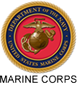

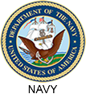

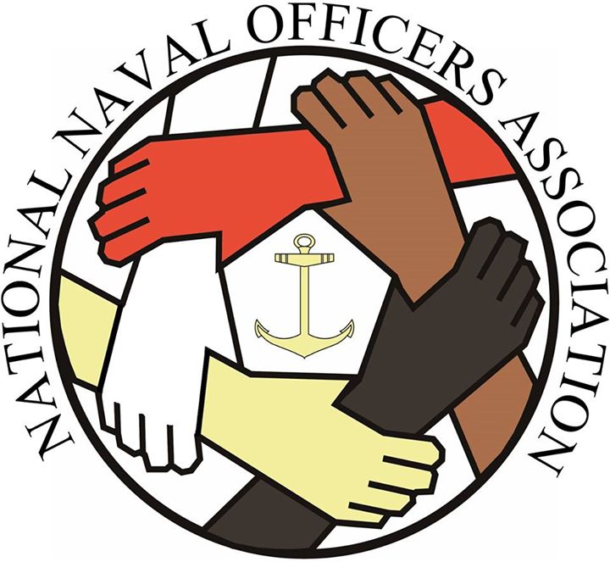

**CAMP LEJEUNE/ CHERRY POINT CHAPTER**

**PO BOX 9844**

**Camp Lejeune, NC 28547**

**SERVING THE SEA SERVICES**

AND THE COMMUNITY

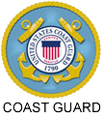

**NNOA GUIDING PRINCIPLES**

We are an inclusive organization that seeks diversity in our membership.

We value all members and are committed to treating everyone with dignity, respecting individual differences and affirming organizational and personal strengths.

We are TEAM NNOA composed of active duty, reserve and retired officers and civilians.

We achieve our mission and vision through enthusiastic support and dedicated service at the national and local levels.

We are an organization of professionals whose accomplishments are attained through teamwork and accountability.

We are dedicated to the professional development of our members.

We promote an atmosphere conducive to self-improvement and forward thinking.

We promote honest, effective and open communications.

We communicate and process information using the best resources and technology available.

We are dedicated to helping the Sea Services achieve their recruitment, retention and readiness goals.

We recognize achievements and maintain our valued reputation.

**CHAPTER OFFICERS**

President: LT Fears

VP: LCDR Walker

Treasurer: 2Lt Ramsuer

Secretary: Mrs. Lewis

Membership: Maj Whitaker

Public Relations: 2Lt Boyd  
Historian: 2Lt St. John

Chaplain: LT Jefferson

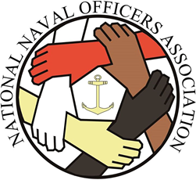

**Camp Lejeune/Cherry Point Chapter meetings are held monthly on the second Thursday at 1730 in the Paradise Point Officers Club,   
Division Room.**

**For more information contact**:

***LT Burnetta Fears***

***(910) 450-3172***

***burnetta.f.fears.mil@mail.mil***

**CHAPTER ACTIVITIES**

- Professional Development  
- Mentoring

- High School Scholarship  
 Program

- Community Service Projects

- Membership Socials

**NNOA MISSION**

**To enhance Sea Service operational readiness by providing professional development, mentoring and recruiting in an effort to achieve a diverse officer corps that reflects the demographics of the nation.**

**NNOA VISION STATEMENT**

**“Strengthening of a diverse officer corps to enhance operational readiness in the Sea Services”**